Labaratoriya 10

CSS transition va animatsiya elementlarini yaratish

KIRISH
Zamonaviy veb-saytlar foydalanuvchi tajribasini (UX) yaxshilash va interfeysni jozibador qilish uchun turli dinamika va vizual effektlardan foydalanadi. Shunday vositalardan biri – bu CSS transition va animatsiya texnologiyalari.
Transitionlar elementdagi o‘zgarishlarni yumshoq o‘tish bilan amalga oshirsa, animatsiyalar esa elementga murakkab, ketma-ket va avtomatik harakatlar berishga imkon yaratadi. Ushbu mavzu veb-dizayn, UI/UX, front-end dasturlashda juda muhim o‘rin tutadi.
ASOSIY QISM

1. CSS Transition tushunchasi
Transition – element holati o‘zgarganda (masalan hover, focus, active) sodir bo‘ladigan o‘tish effektidir. Bu jarayonda o‘zgarishlar birdaniga emas, balki ma’lum vaqt davomida asta-sekin amalga oshadi.

Transitionning asosiy xossalari:
transition-property – o‘zgartiriladigan xususiyat
transition-duration – davomiylik
transition-timing-function – tezlikning taqsimlanishi
transition-delay – kechikish

Misol:
.box {
width: 100px;
height: 100px;
background: blue;
transition: all 0.5s ease;
}
.box:hover {
background: red;
width: 150px;
}
Ushbu kodda elementga hover qilinganda rang va o‘lcham 0.5 sekund ichida asta-sekin o‘zgaradi.

2. CSS Animation tushunchasi
Animation – elementda bir necha bosqichdan iborat harakatlarni bajarish imkonini beruvchi kuchli vosita. Transitiondan farqli ravishda animatsiya avtomatik ishlashi mumkin va o‘zgarishlar bir nechta bosqich orqali belgilanadi.

Animationning asosiy elementlari:
@keyframes – animatsiyaning bosqichlari (0%–100%)
animation-name
animation-duration
animation-iteration-count
animation-direction
animation-fill-mode
animation-delay

Misol:
.ball {
width: 50px;
height: 50px;
background: green;
border-radius: 50%;
animation: move 3s infinite;
}
@keyframes move {
0% { transform: translateX(0); }
50% { transform: translateX(200px); }
100% { transform: translateX(0); }
}
Bu animatsiya doirani chapdan o‘ngga harakatlantiradi va doim takrorlanadi.

3. Transition va Animation o‘rtasidagi farqlar
Transition | Animation
Holat o‘zgarganda ishga tushadi | Mustaqil ishlashi mumkin
Oddiy o‘tishlar uchun | Murakkab harakatlar uchun
Keyframes talab qilinmaydi | @keyframes talab qilinadi
Hover, focus kabi holatlarga bog‘liq | Avtomatik yoki trigger bilan ishlaydi

4. Amaliy qo‘llanilishi
tugmalar hover effektlari
menyular ochilishi
rasm ustida zoom effektlar
loaderlar (aylanish, sakrash)
banner animatsiyalari
ikonkalarning jonlanishi
Transitionlar asosan UX uchun zarur bo‘lsa, animatsiyalar veb-dizaynni jonlantirish va foydalanuvchi diqqatini jalb qilish uchun ishlatiladi.
Amaliy qismi:
<!DOCTYPE html>
<html lang="uz">
<head>
<meta charset="UTF-8">
<title>Avto Salon — Transition va Animatsiya</title>

<style>
body {
margin: 0;
font-family: 'Poppins', sans-serif;
background: linear-gradient(135deg, #eceff1, #e3f2fd);
}

header {
text-align: center;
padding: 30px;
background: #263238;
color: white;
border-bottom-left-radius: 25px;
border-bottom-right-radius: 25px;
}

h1 {
margin: 0;
font-size: 38px;
}

.section {
max-width: 1100px;
margin: auto;
padding: 40px;
}

/* ======== AVTO SALON — TRANSITION KARTOCHKALAR ======== */

.cars {
display: grid;
grid-template-columns: repeat(3, 1fr);
gap: 25px;
}

.car {
background: white;
border-radius: 20px;
overflow: hidden;
box-shadow: 0 6px 16px rgba(0,0,0,0.15);
transition: transform 0.4s ease, box-shadow 0.4s ease;
}

.car:hover {
transform: translateY(-12px) scale(1.03);
box-shadow: 0 12px 28px rgba(0,0,0,0.3);
}

.car img {
width: 100%;
height: 210px;
object-fit: cover;
}

.content {
padding: 15px;
}

.title {
font-size: 22px;
margin: 0;
color: #0d47a1;
}

.type {
margin-top: 4px;
font-weight: bold;
color: #1565c0;
}

.desc {
color: #424242;
margin-top: 8px;
}

/* ======== CSS ANIMATION — AVTOMOBILLAR ======== */

.animation-title {
text-align: center;
margin-top: 60px;
font-size: 30px;
color: #c62828;
}

.anim-area {
display: flex;
justify-content: space-around;
padding: 40px 0;
flex-wrap: wrap;
}

/* Mashina yuradi */
@keyframes moveCar {
0% { transform: translateX(0); }
50% { transform: translateX(100px); }
100% { transform: translateX(0); }
}
.car-move {
width: 180px;
animation: moveCar 2.5s infinite ease-in-out;
}

/* SUV sakraydi */
@keyframes bounce {
0% { transform: translateY(0); }
50% { transform: translateY(-30px); }
100% { transform: translateY(0); }
}
.car-bounce {
width: 180px;
animation: bounce 1.6s infinite;
}

/* G‘ildirak aylanishi */
@keyframes rotateWheel {
0% { transform: rotate(0); }
100% { transform: rotate(360deg); }
}
.wheel {
width: 130px;
animation: rotateWheel 2s infinite linear;
}

/* RESPONSIVE */
@media (max-width: 1000px) {
.cars {
grid-template-columns: repeat(2, 1fr);
}
}

@media (max-width: 700px) {
.cars {
grid-template-columns: 1fr;
}
header h1 {
font-size: 30px;
}
.anim-area {
flex-direction: column;
align-items: center;
gap: 30px;
}
}

</style>
</head>
<body>

<header>
<h1>🚗 Avto Salon — Transition & Animation</h1>
<p>Zamonaviy avtomobillar bilan interaktiv sayt</p>
</header>

<section class="section">

<h2>🚘 Avtomobillar — Transition kartochkalar</h2>

<div class="cars">

<div class="car">
<img src="rasm 7.jfif" alt="">
<div class="content">
<h3 class="title">BMW X5</h3>
<p class="type">Premium SUV</p>
<p class="desc">Kuchli dvigatel, hashamatli salon va zamonaviy texnologiyalar.</p>
</div>
</div>

<div class="car">
<img src="rasm 11.webp" alt="">
<div class="content">
<h3 class="title">Mercedes-Benz C-Class</h3>
<p class="type">Biznes Sedan</p>
<p class="desc">Qulaylik, ishonchlilik va yuqori darajadagi dizayn.</p>
</div>
</div>

<div class="car">
<img src="rasm10.jpeg" alt="">
<div class="content">
<h3 class="title">Chevrolet Malibu</h3>
<p class="type">Shahar Sedan</p>
<p class="desc">Yonilg‘i tejamkor va kundalik foydalanish uchun ideal.</p>
</div>
</div>

</div>

</section>

<h2 class="animation-title">✨ CSS Animatsiya — Avtomobillar harakatda</h2>

<section class="anim-area">

<img class="car-move" src="https://cdn-icons-png.flaticon.com/512/743/743131.png" alt="Car">

<img class="car-bounce" src="https://cdn-icons-png.flaticon.com/512/1048/1048315.png" alt="SUV">

<img class="wheel" src="https://cdn-icons-png.flaticon.com/512/169/169874.png" alt="Wheel">

</section>

</body>
</html>

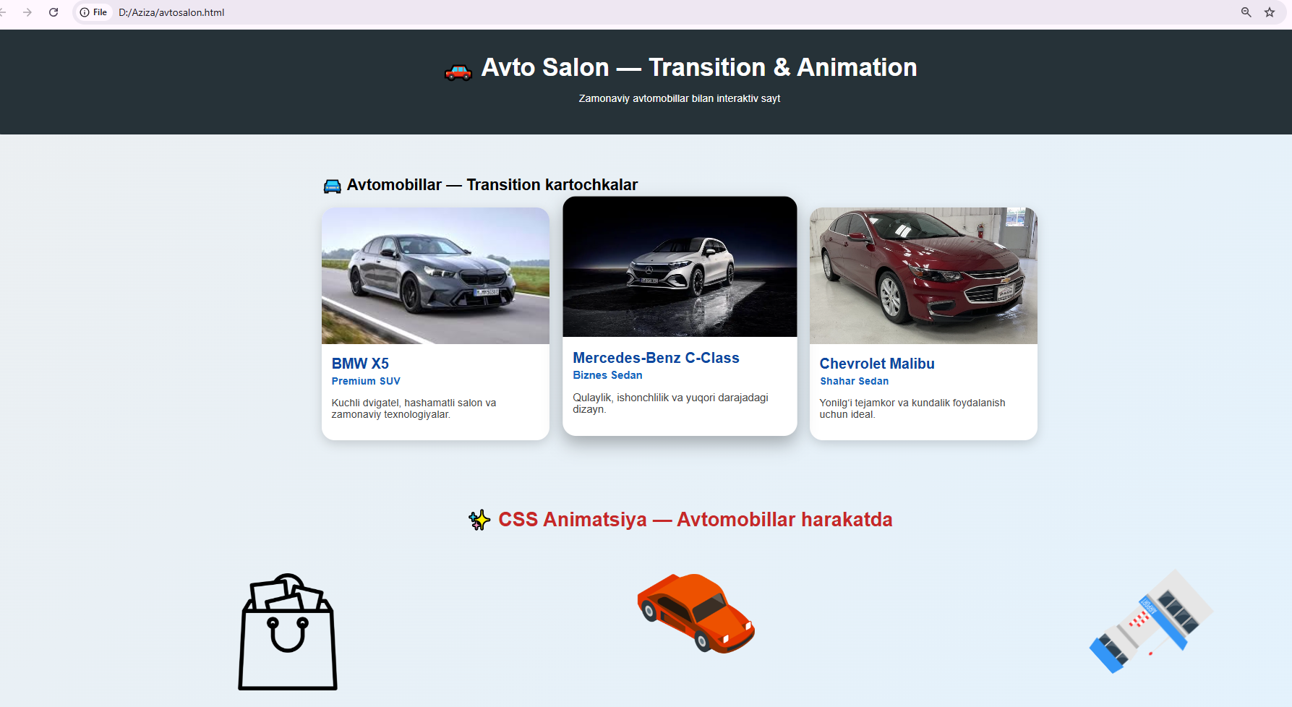

XULOSA
CSS transition va animation — frontend ishlab chiqishda juda muhim texnologiyalar bo‘lib, ular yordamida veb-sahifaga joziba, dinamika va professional ko‘rinish berish mumkin. Transitionlar kichik va yumshoq o‘tishlar uchun qulay bo‘lsa, animatsiyalar murakkab harakatlar, bannerlar va jonli effektlar yaratish imkonini beradi. Ushbu texnologiyalarni puxta o‘rganish dizayner yoki dasturchiga interfeysni yanada qulay, jozibador va interaktiv qilishi mumkin.

